A Knowledge-Based Recommendation System That Includes Sentiment Analysis and Deep Learning

Now-a-days all peoples are using online social networks (OSN) to express their views on any matter like politics, sports, educations, personal problems etc. User post their views on OSN networks and in this paper author is analysing those post or messages with deep learning BLSTM (Bidirectional Long Short Term Memory (Neural Network) to detect user’s mental conditions. In this paper first BLSTM will be trained with accessor (or OSN messages dataset) messages and then application will read OSN messages to detect user mental condition. BLSTM will predict state by analysing OSN messages from -5 to + 5 range. If user messages contains stressed words such as SAD, Lonely, failure lost etc then BLSTM will assign that message with negative sentiment and then ask application to recommend positive or motivational messages to such user.

All existing application using traditional algorithms such as Random Forest or SVM to detect sentiments from user messages but those algorithms accuracy is not better and they are not maintaining user personal information such as their personal profile to send motivational messages in ontologies. Propose work maintain all user details such as personal or professional profile, sleeping hours and age etc.

In this paper author propose concept called eSM2 (sentiment metric) with Knowledge Based Recommendation System (KBRS). Using eSM2 we will detect sentiment intensity from messages and then using KBRS we will recommend motivational messages to users. Working procedure of this technique describe below

The KBRS contains the emotional health monitoring system, which uses the deep learning model and the sentiment metric named eSM2. The sentences are extracted from an OSN and then emotional health monitoring system identifies which sentences present a stress or depression content using machine learning algorithms and the emotion of the sentence content. The monitoring system is able to send warning message to people that are previously registered. Later, the selected sentences are analysed by the sentiment metric (eSM2) and the sentiment intensity is used as input of the recommendation engine. The KBRS server establishes a communication with the KBRS client application, in which the user receives a specific message according to his/her profile, ontology aspects, and the sentiment value calculated from his/her sentences extracted from OSNs.

To implement this project author has built his dataset by hiring accessor and make them to write sentences on OSN networks and then by using those sentences he train BLSTM and random forest algorithm but here we don’t have any person to write OSN sentences so I am directly using OSN dataset from twitter and then training BLSTM and Random forest train model to calculate their accuracy and to predict sentiment from new test messages.

This project consists of following modules

1. Upload OSN dataset: Using this module we will upload dataset to application
2. Generate Train & Test Model From OSN Dataset: Using this module we will read all messages from dataset and build a train and test model by extracting features from dataset.
3. Build CNN BLSTM-RNN Model Using Softmax: Using this module we will build deep learning BLSTM model on dataset and then using test data we will calculate BLSTM prediction accuracy.
4. Run Random Forest Algorithm: for accuracy comparison between BLSTM and random forest we are running this algorithm also.
5. Upload Test Message & Predict Sentiment & Stress: Using this module we will upload test messages and then application will detect stress by applying BLSTM model on test data.
6. Accuracy Graph: using this will display accuracy comparison graph between BLSTM and random forest.

Below are some test messages used to detect stress

**Check this video out President Obama at the White House Correspondents Dinner 😜**

**Karoli I firmly believe that ObamaPelosi have ZERO desire to be civil Its a charade and a slogan but they want to destroy conservatism 😭**

**😍**

**😭**

**😜**

**i am stressed**

**completely lost**

All bold sentences are test messages and this messages contain emoticons also. When we upload this test messages to application then application detect stress and request for motivational messages. Some time users just post emoticons to express their emotions instead of message and this application consider those emoticons also.

Screen shots

To run this project first double click on ‘download_nltk.bat’ file to download natural language processing API. This API helps in removing stop words or special symbols from messages. After downloading and installing this software you can click on ‘run.bat’ file to execute project and to get below screen

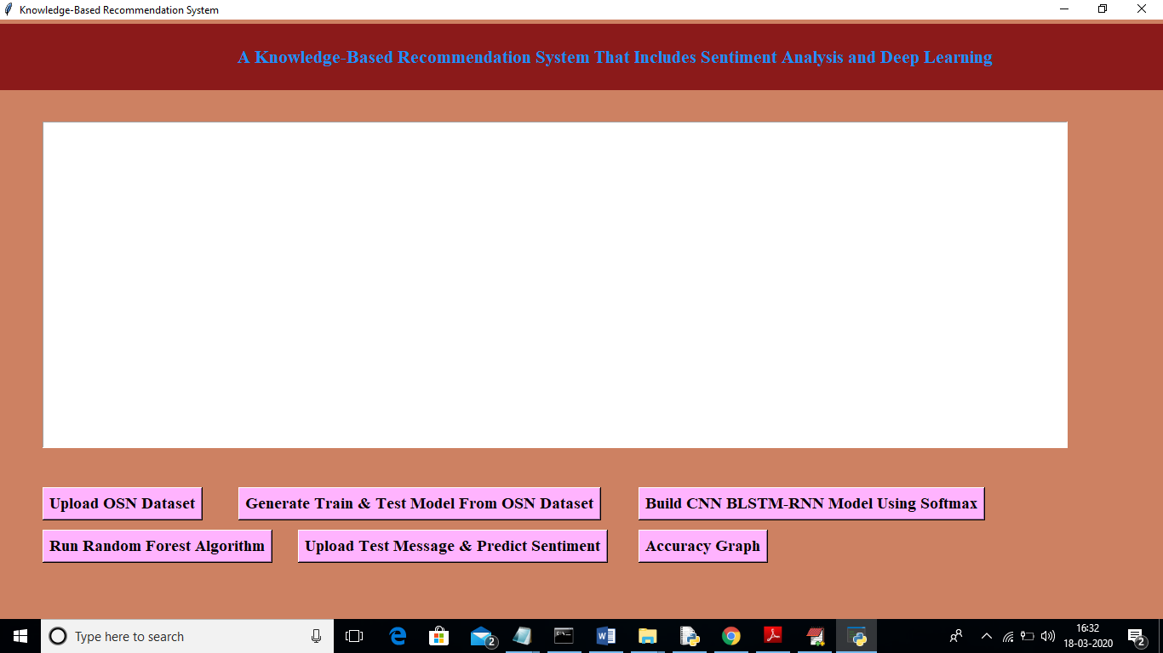

In above screen click on ‘Upload OSN Dataset’ button to upload OSN dataset

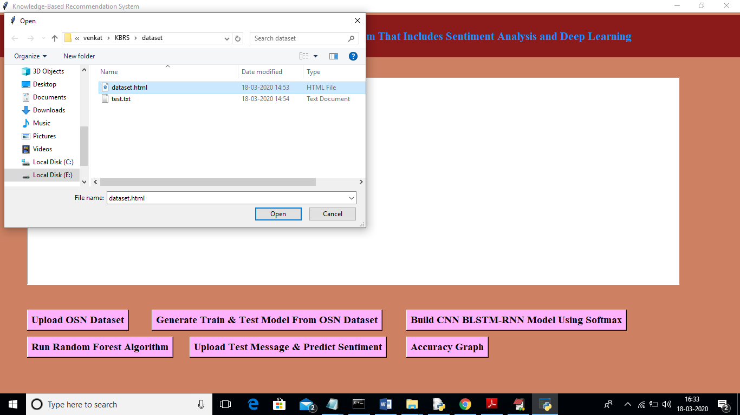

In above screen I am uploading ‘dataset.html’ file which contain OSN messages. After uploading dataset will get below screen

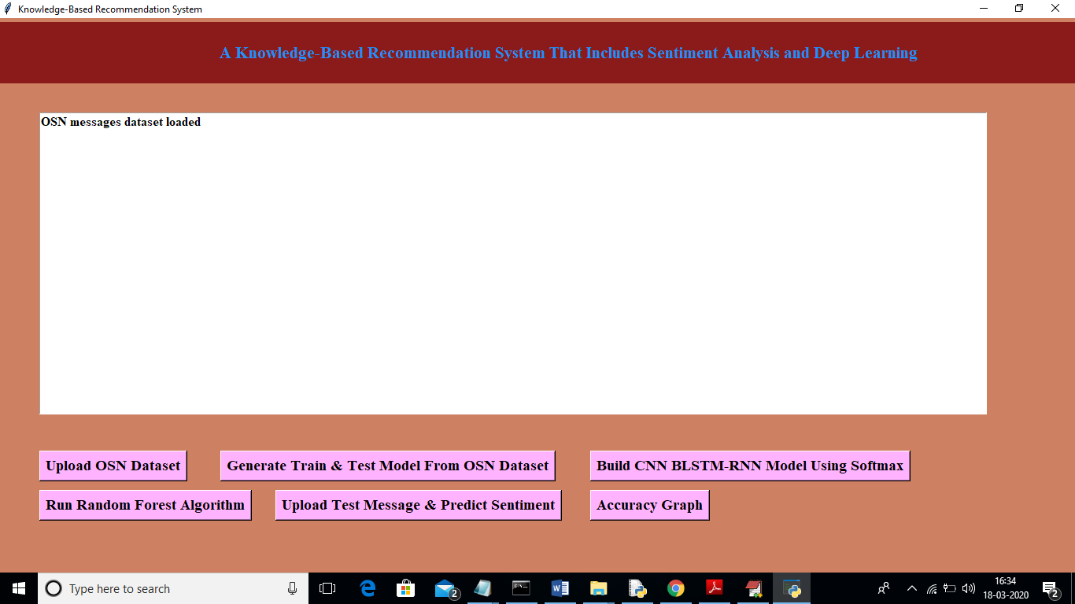

Now click on ‘Generate Train & Test Model From OSN Dataset’ button to read dataset and to extract features from dataset such as total messages and words etc.

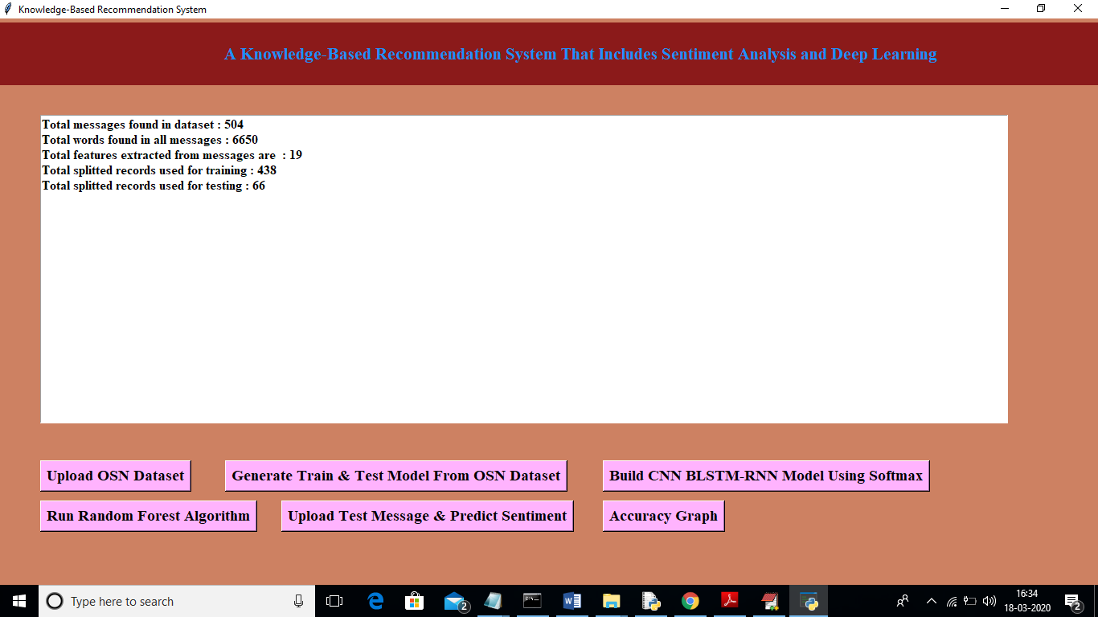

In above screen we can see dataset contains total 504 messages and all messages contains 6650 words and application using 438 records for BLSMT training and 66 records to test BLSTM accuracy or prediction performance. Now click on ‘Build CNN BLSTM-RNN Model Using Softmax’ button to train dataset features with BLSTM model.

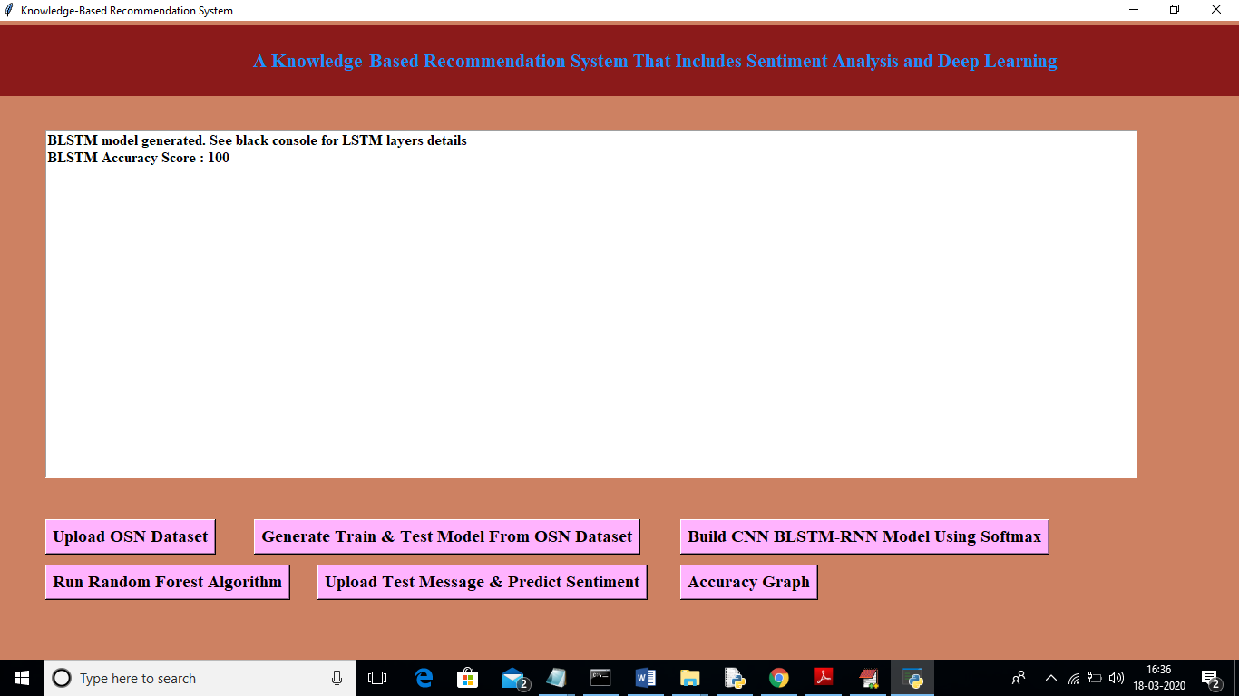

In above screen we can see BLSTM model generated and its prediction accuracy is 100% and now we can see black console below to see BLSTM accuracy and epoch details

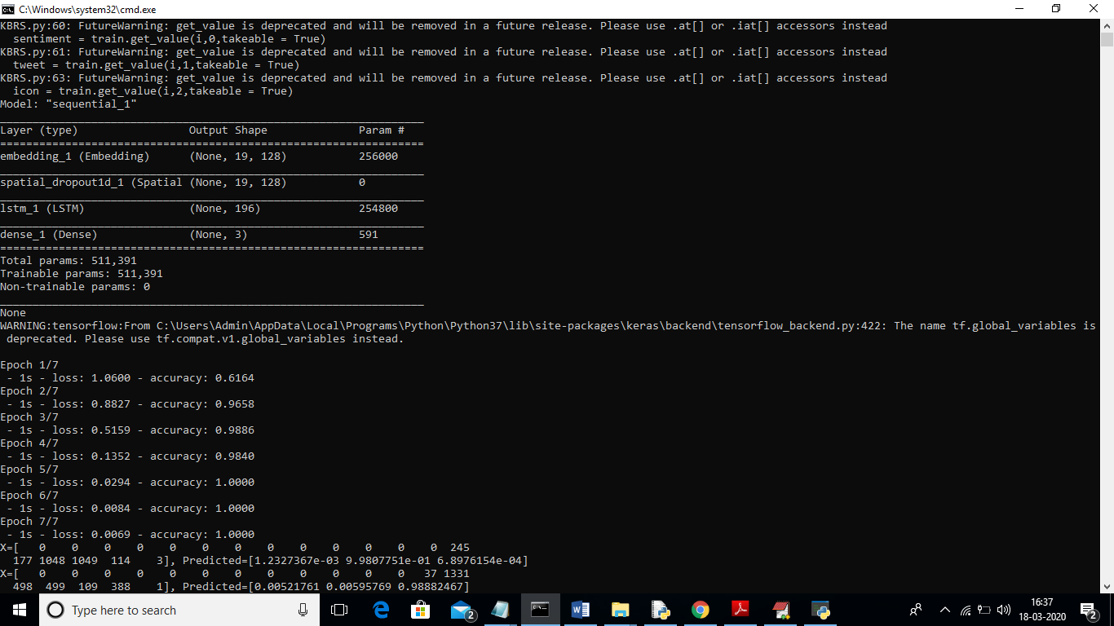

In above screen we can see BLSTM taking total 7 iterations to generate prediction layers and each layer we can see its prediction accuracy got better. In first iteration BLSTM accuracy was 0.61 then moves to 0.96 and finally we 1 accuracy which means 100%. Now click on ‘Run Random Forest Algorithm’ button to build random forest train model.

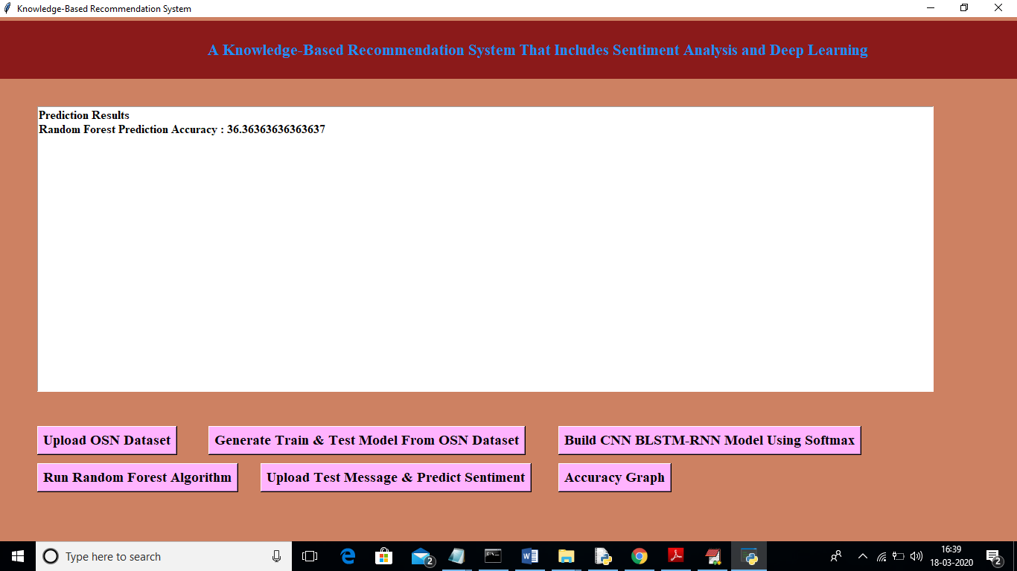

In above screen we can see random forest prediction accuracy is 36% which is lower than propose BLSTM accuracy. Now click on ‘Upload Test Message & Predict Sentiment & Stress’ button to upload test messages file and to detect stress from those messages

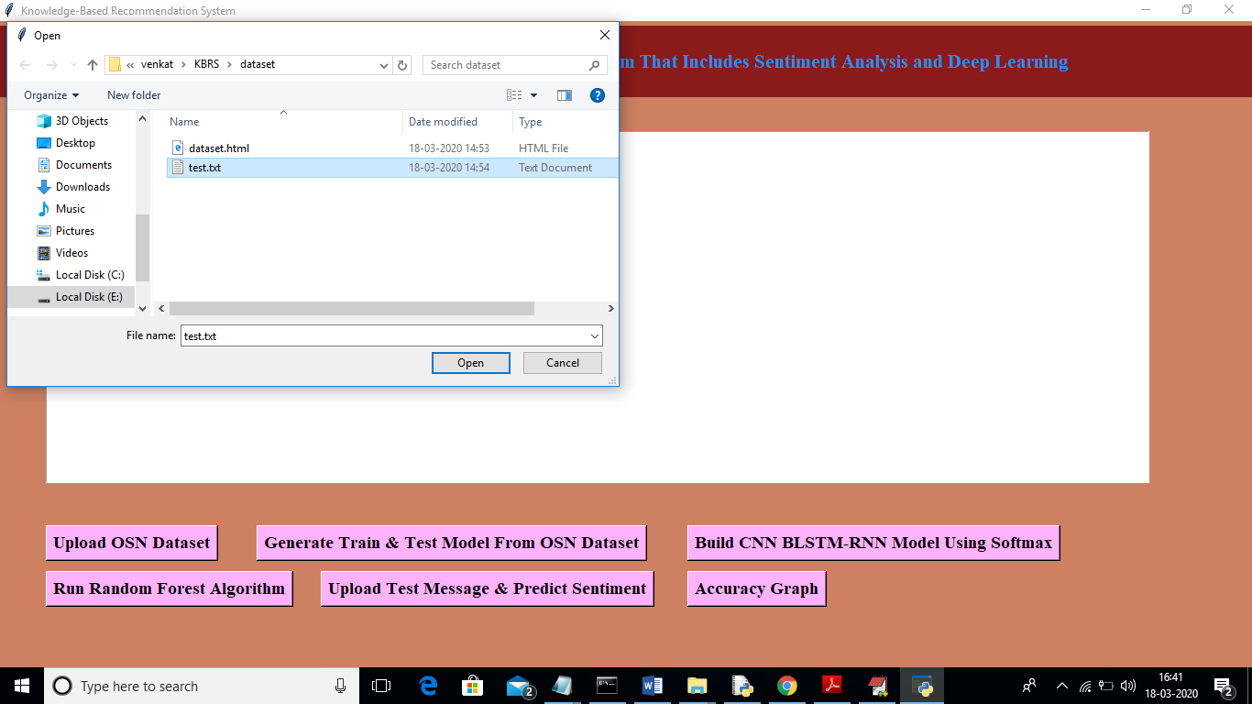

In above screen I am uploading ‘test.txt’ file which contains OSN messages and now click on ‘Open’ button to get below result

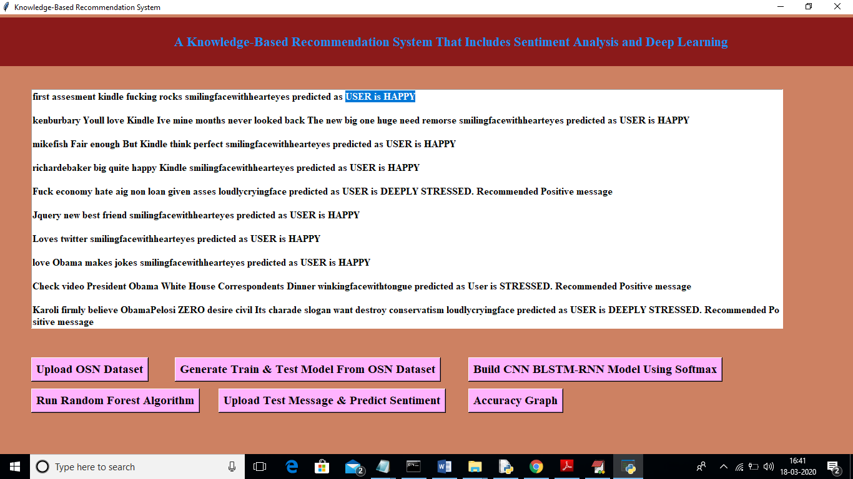

In above screen we can see beside each message application detected and mark with stress or non-stress status. If user detected under stress then application recommend for motivational message. In above screen I can’t display EMOTICONS so I am displaying their names like ‘smilingfacewithhearteyes’ or ‘loudlycryingface’ etc. so in above screen by using BLSTM we detect stress from all messages. Now click on ‘Accuracy Graph’ button to get below graph

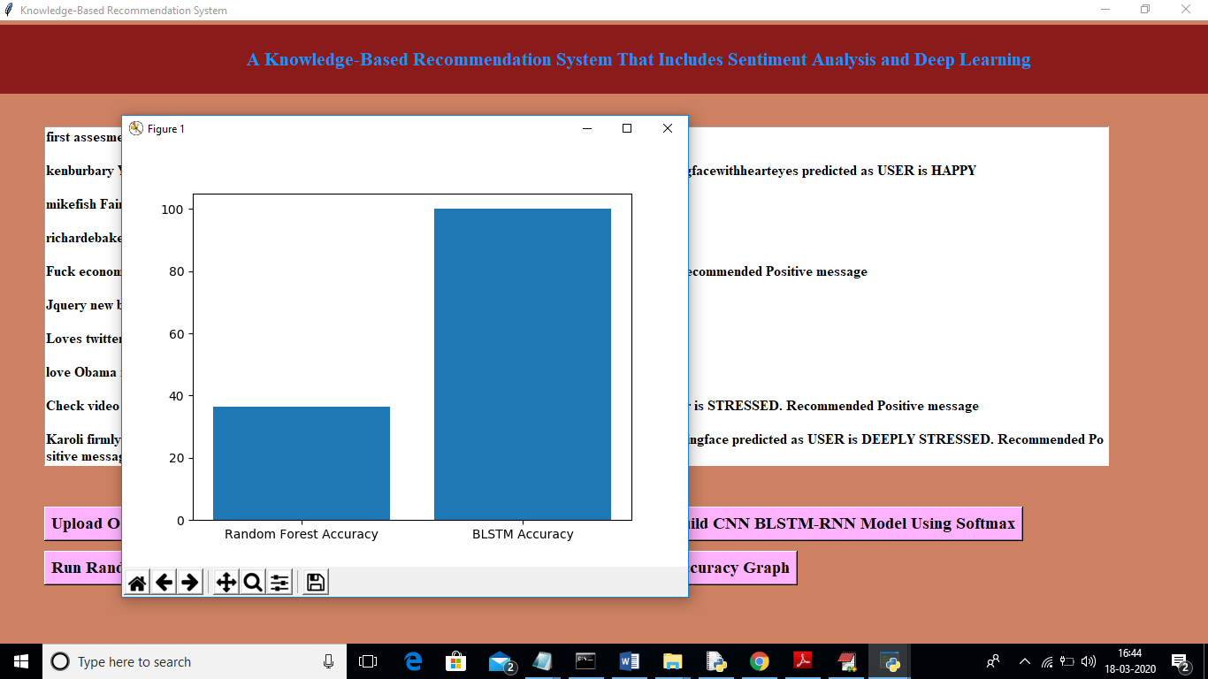

In above graph x-axis represents algorithm name and y-axis represents accuracy of those algorithms. From above graph we can conclude that BLSTM is much better than traditional Random Forest Algorithm.